# **MPM-toolbox**

## **AIMS**

MPM-functions to run the hMRI-toolbox for rodent data (mouse/rat), i.e. for quantitative MRI.

For hMRI-toolbox see: <https://www.cbs.mpg.de/abteilungen/neurophysik/software/hmri-toolbox>

**I) Pipeline with pre-processing steps (ANTx is necessary)**

**SET paths, open ANTx-GUI and create project-file**

**IMPORT BRUKER DATA**

**Starting mpm-GUI**

**Configure mpm-setup and parameter files**

**LOAD AND RUN THE MPM-PIPELINE**

**Processing steps … some information**

**Misc. “estimate pre-orientation”**

**II) Working without pre-processing steps (ANTx is not necessary)**

**SET mpm-PATH**

**SETUP and configuration**

**Loading the ‘mpm_config.m’-file**

**Select animals for processing**

**RUN the hMRI-processing steps**

**I) Pipeline with pre-processing steps (ANTx is necessary)**

**SET paths, open ANTx-GUI and create project-file**

-start Matlab

-add ANTx-path via hyperlink or go to ANTx-folder and type “**antlink**” (this will set the paths of ANTx2)

-add mpm-path via hyperlink or go to mpm-folder and type “**mpmlink**” (this will set the paths of mpm)

Set Matlab’s current working directory (dir) to the study folder

My current study-folder is “**F:\data8_MPM\MPM_agBrandt3”**. This folder contains the subfolder ‘raw’ with two raw data-sets (Bruker format).

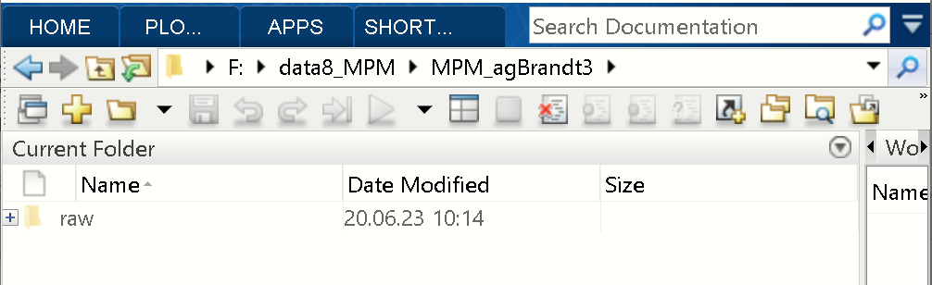

Type “**ant**” in Matlab command window to open the ANT-GUI.

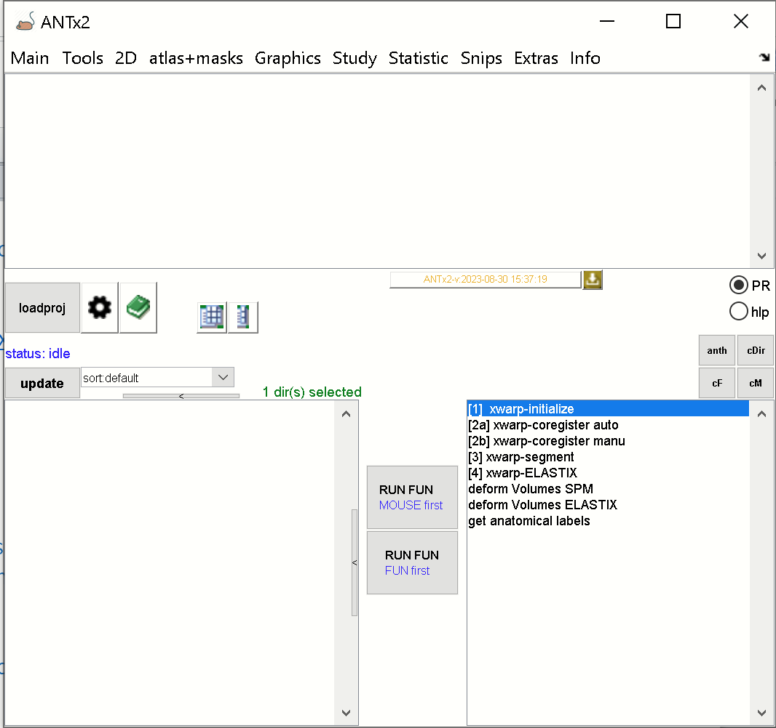

Now, create a new project by selecting **Main/New project** from the menu.

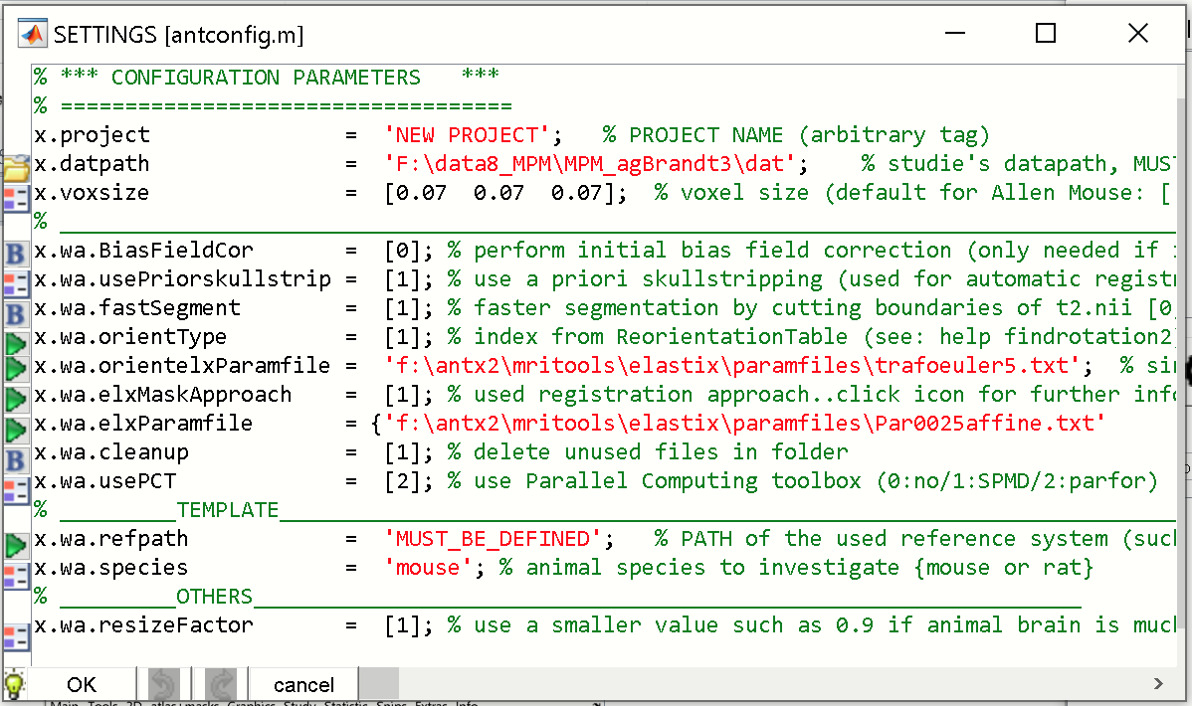

Here you have to specify the reference template. For this, select **green icon** left to “**x.wa.refpath**”:

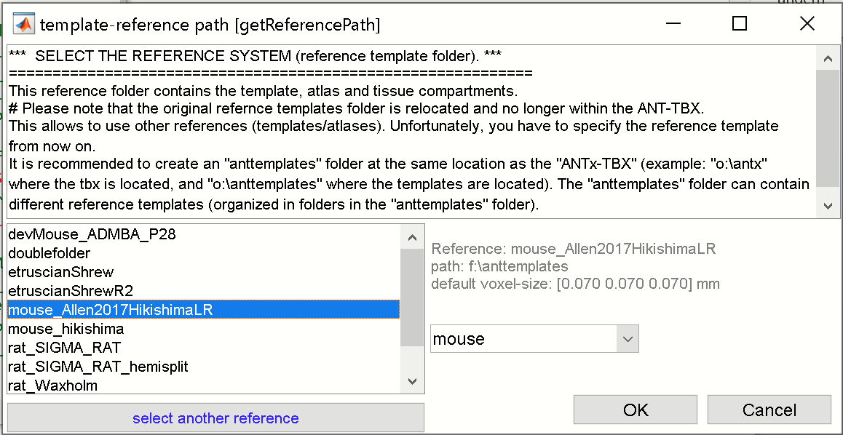

From the template GUI/left listbox select the “**mouse Allen2017HikishimaLR**”-template. Hit [**OK**]-button.

The reference path and the species (x.wa.species is automatically adjusted).

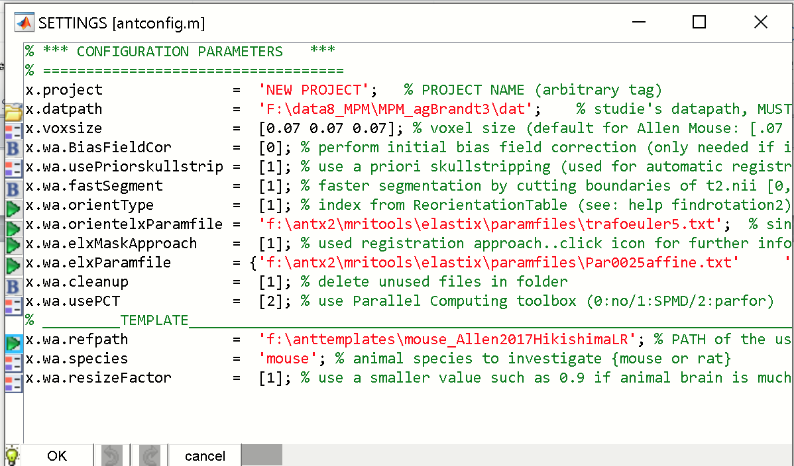

Next, set the following parameters:

x.wa.usePriorskullstrip = 3 🡪 (default is 1; so you can try with 1 )

x.wa.orientType = 11 🡪 this is

The “usePriorskullstrip” variable specifies the mode of skull-stripping that is used for initial rigid registration of the “t2.nii” image to the template (standard-space). The default value of 1 could also work.

The “x.wa.orientType” variable specifies the reorientation of the T1/MT/PD-image based on a rotation-table that is needed to have the same orientation as the template space. For more information see ANTx-tutorial.

The parameter settings shoul**d** know look as follows:

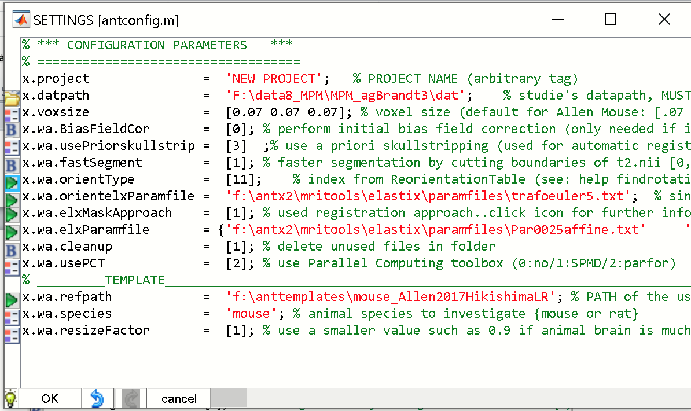

Hit [**OK**]-button. When asked, save the project-file for instance as **“proj.m”-**file in the study folder (here the study folder is “**F:\data8_MPM\MPM_agBrandt3”**). When asked to load the project-file (“proj.m”) click [**yes**]-button.

Now the project-file is defined and loaded into ANT-GUI.

**IMPORT BRUKER DATA**

We next have to import the Bruker data from the raw-folder.

For this click **MAIN/Import Bruker data** from ANT-menu.

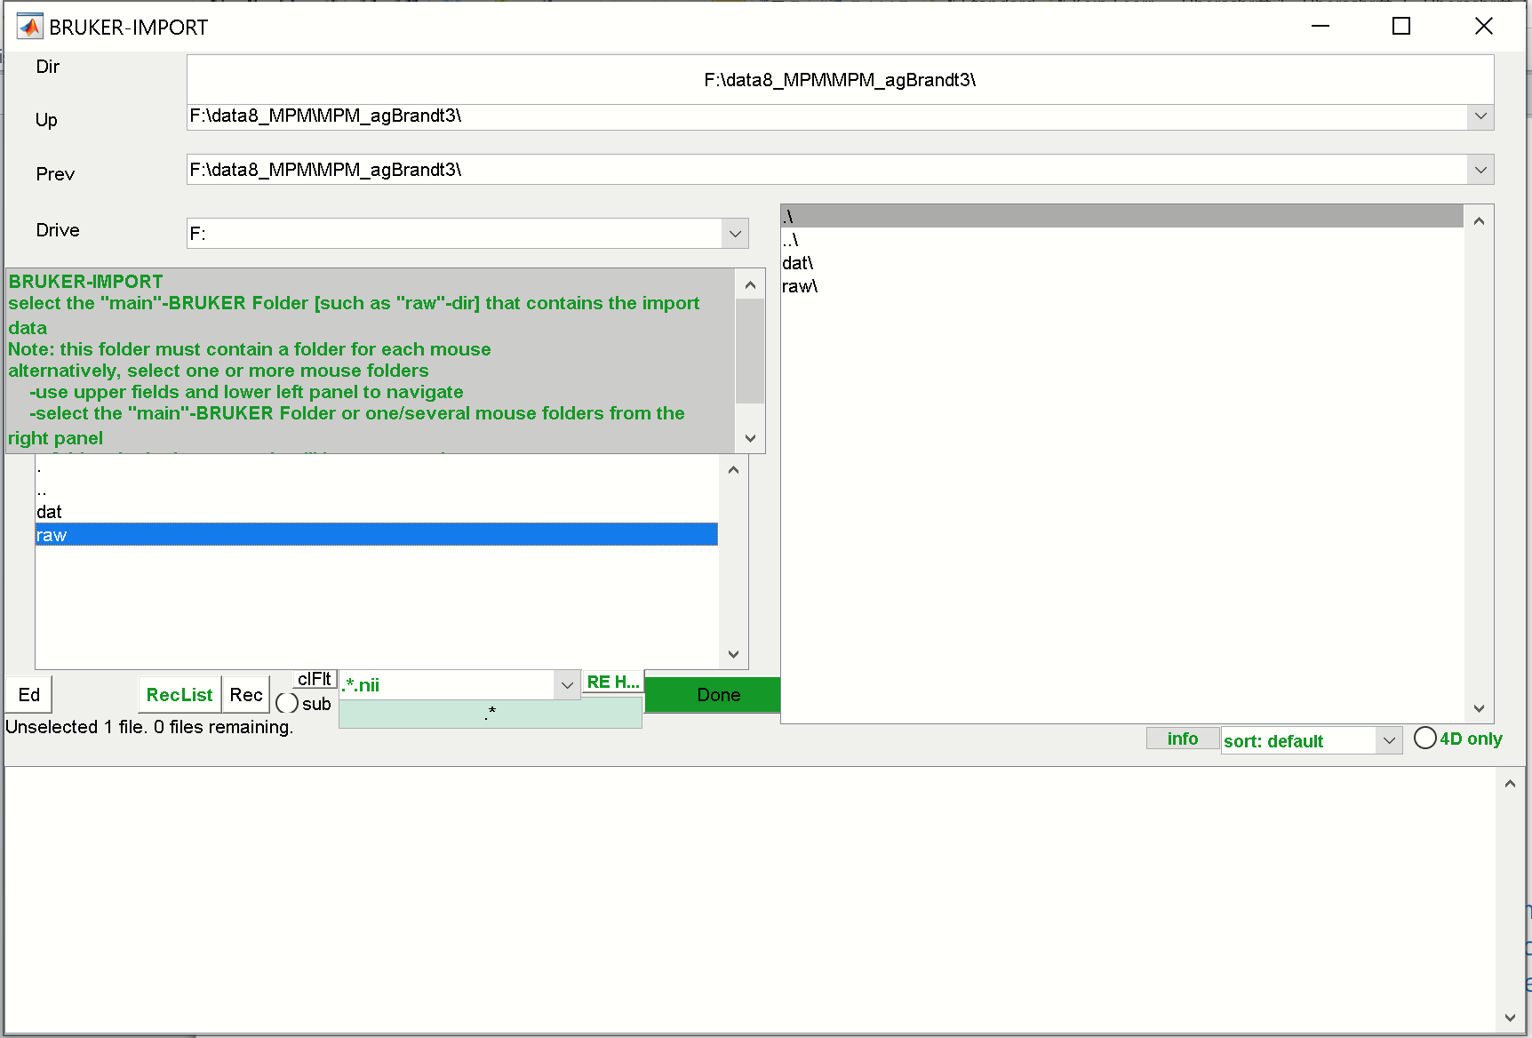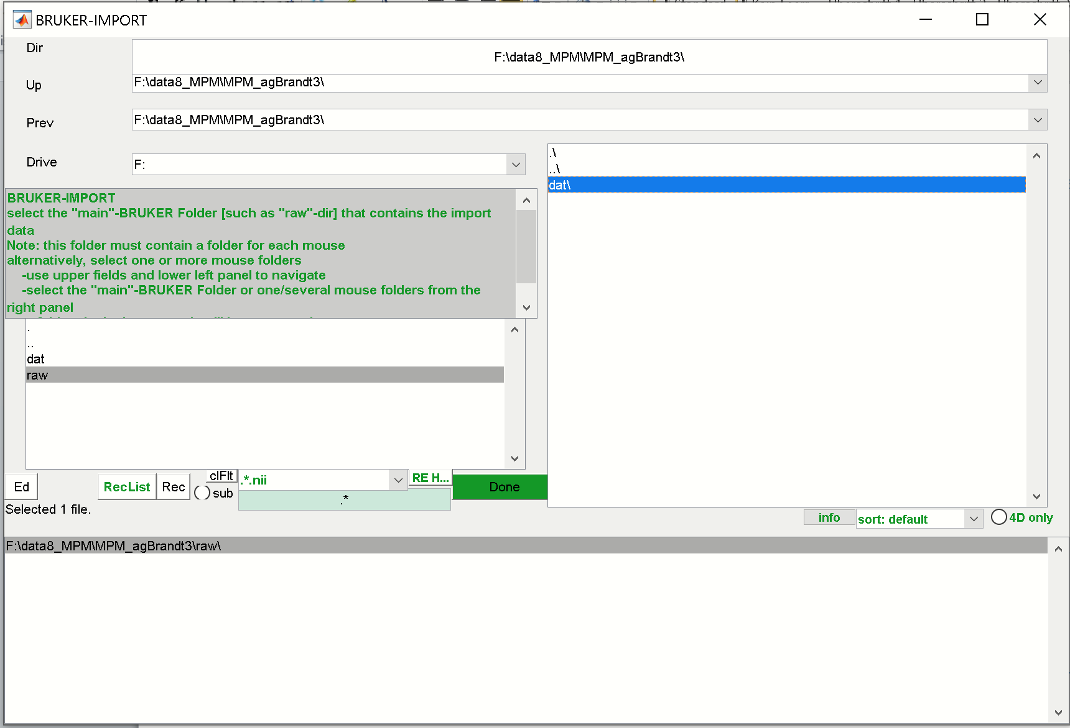

In the Bruker-Import GUI select the “raw”-folder from the right listbox. If selected, this folder will disappear and reappear in the lower listbox. Hit [**Done**]-button.

The next GUI displays all available files found in in the “raw”-folder

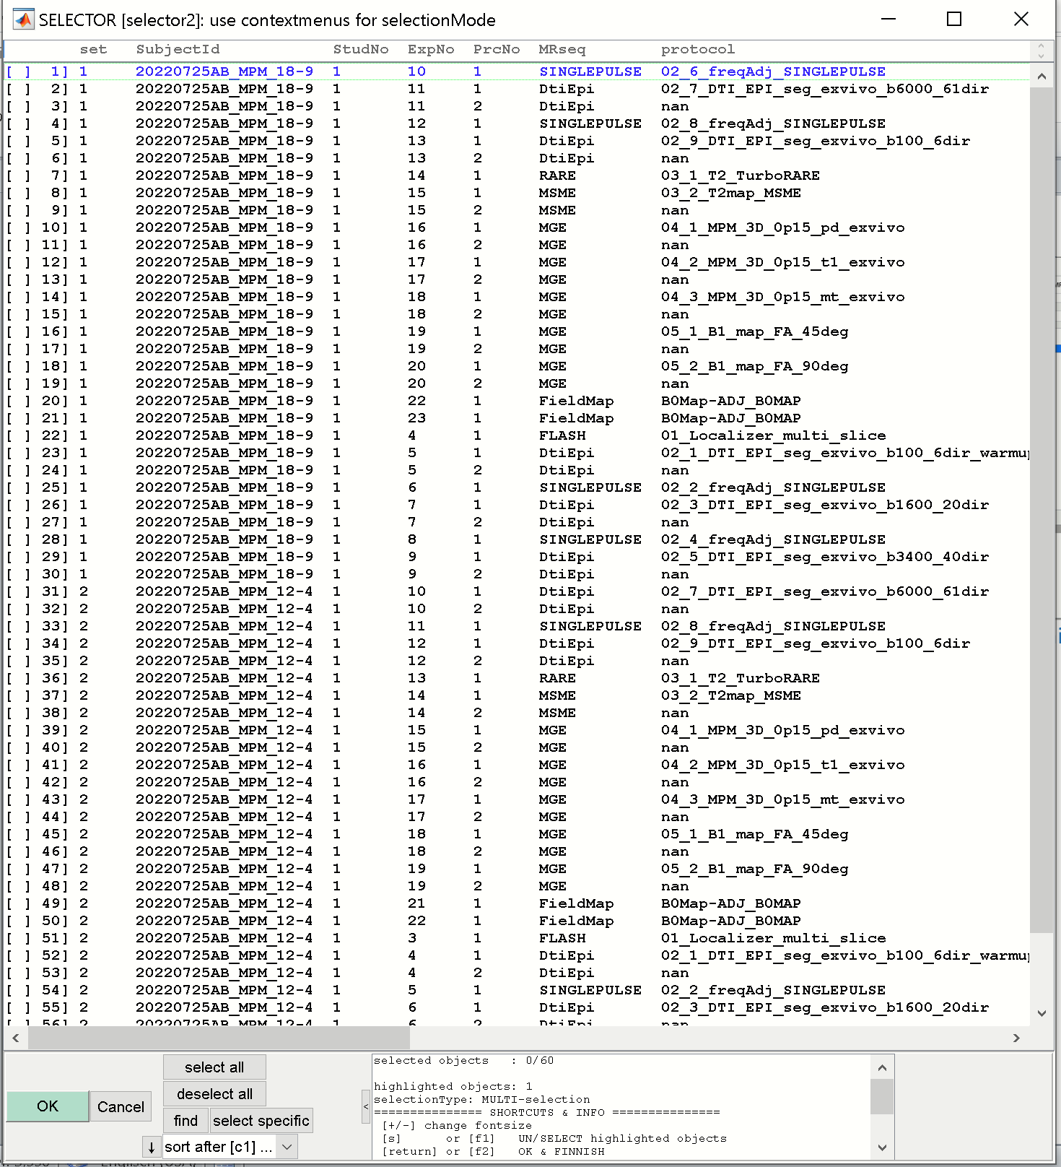

Here we have two datasets (set 1 and 2 in column “set”). Select the turboRARE-file and the PD, T1 and MT-files for each data set.

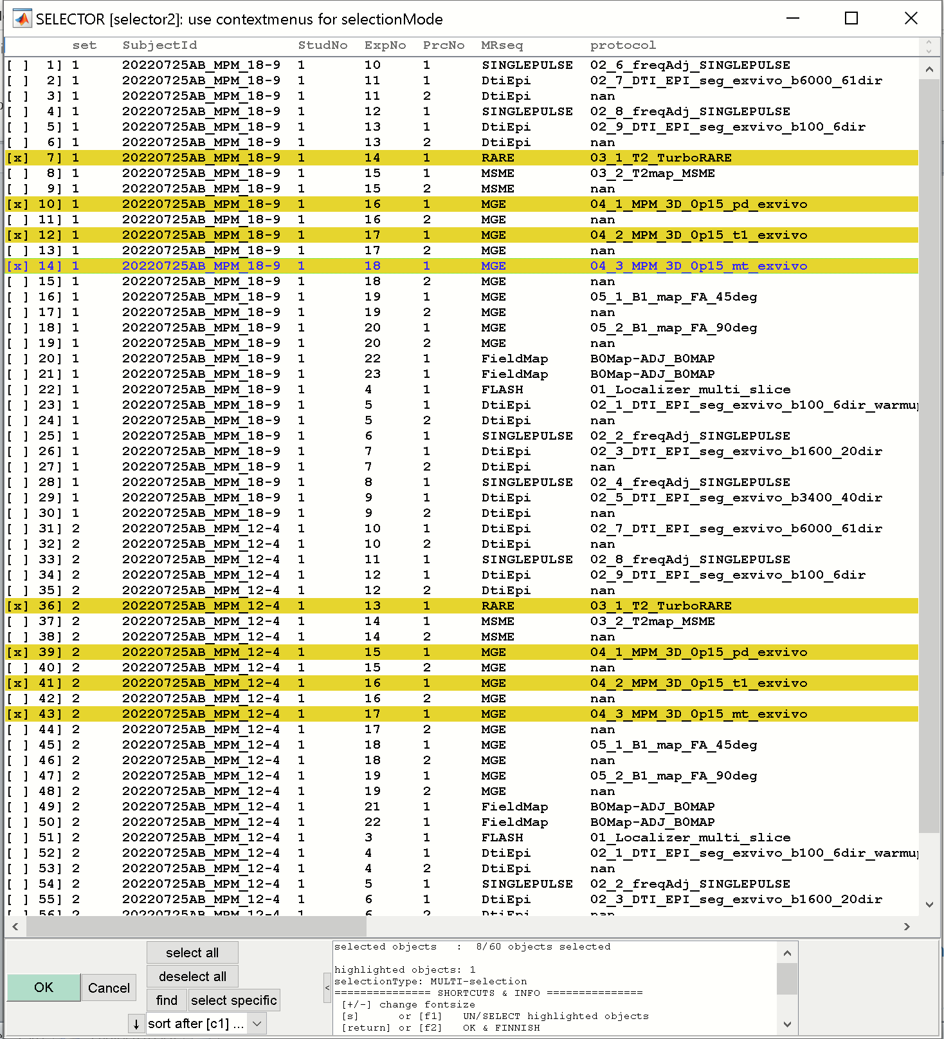

Hit [**OK**]-button to import these files.

Next the Parameter-file for the Bruker-import appears:

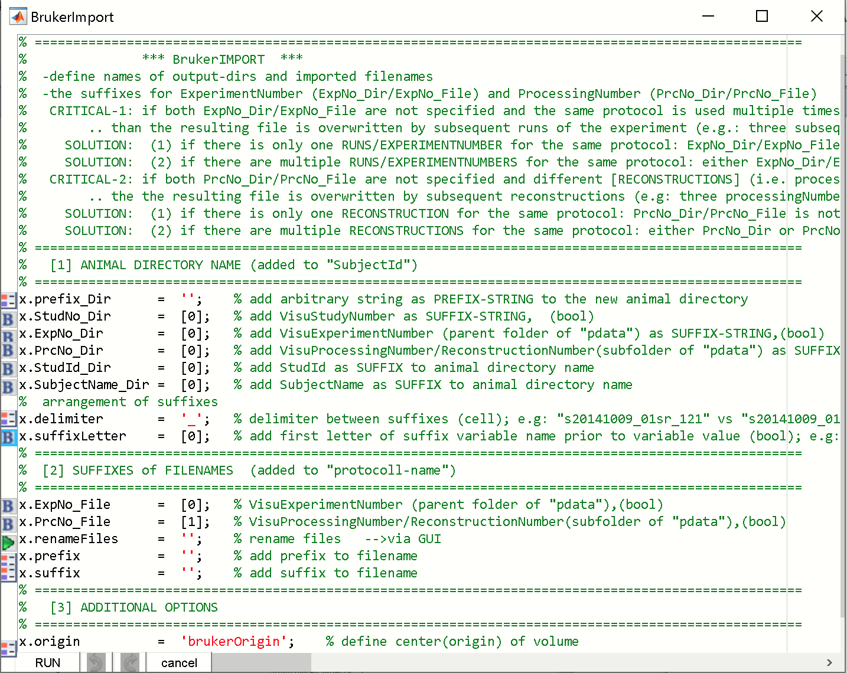

Do nothing here. Hit [**RUN**]-button. The data for the two animals will be imported (“20220725AB_MPM_12-4” & “20220725AB_MPM_18-9”) and when finished the ANT-GUI displays the animals in the left listbox.

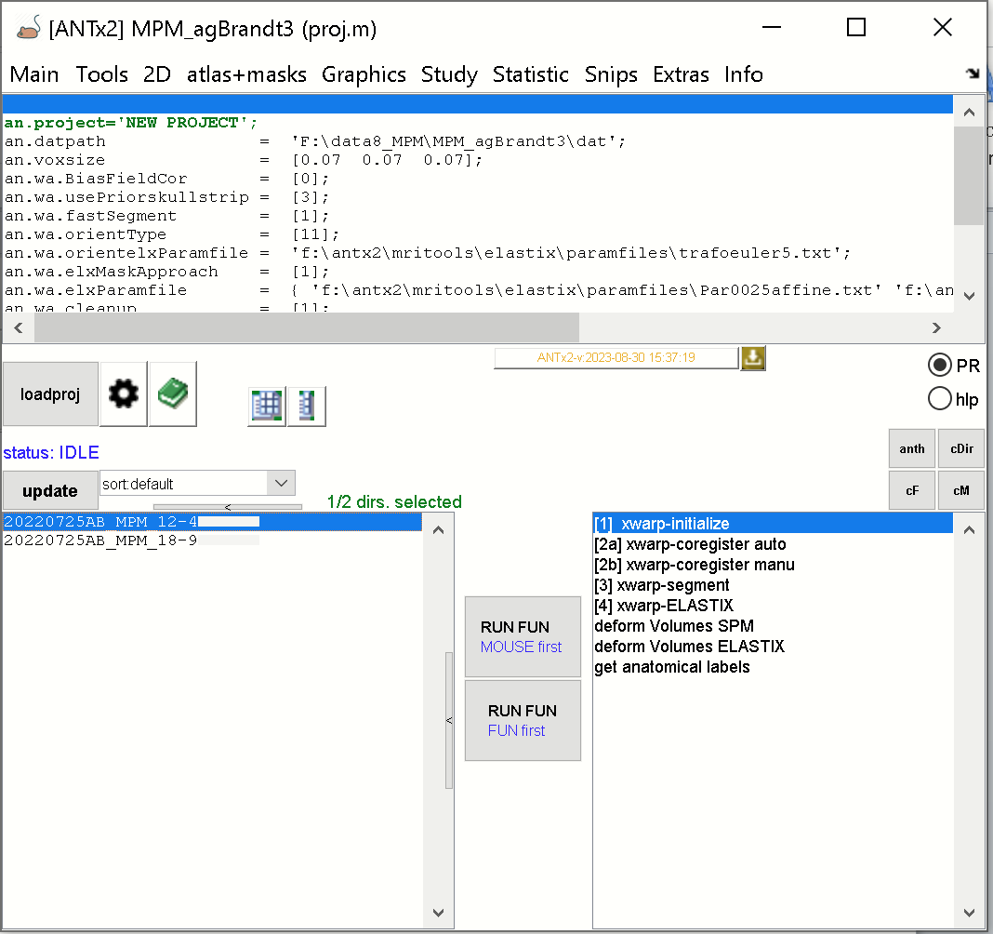

Note that the data of each animal is stored in the “dat”-folder in the current study-folder:

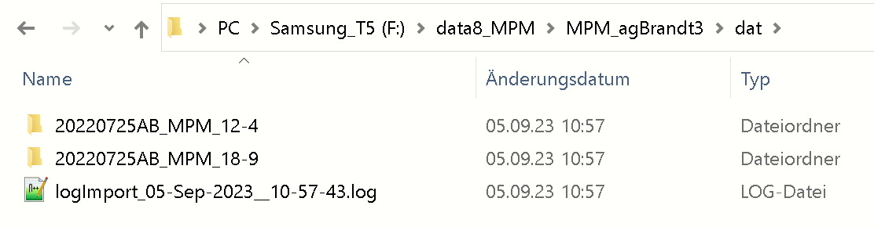

And each animal-folder contains the turboRARE, PD, T1 and MT-files in NIFTI-format (see below):

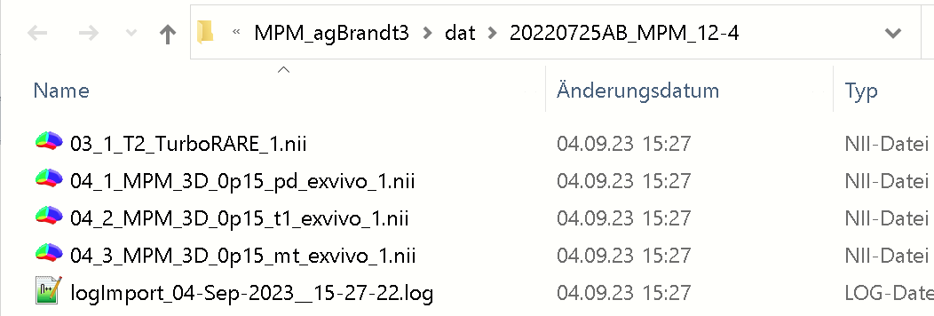

**Starting mpm-GUI**

Set the path of the mpm-wrapper functions now, if not done before (see above).

Type “**mpm**” in Matlab’s command window to start the mpm-GUI.

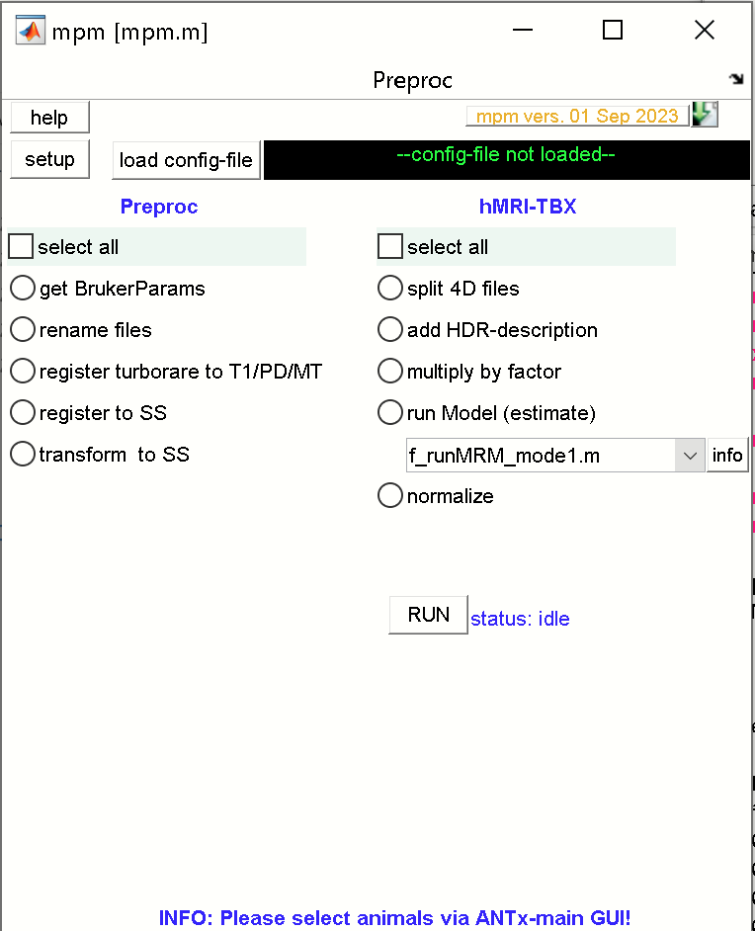

**Configure mpm-setup and parameter files**

Next hit the [**setup**]-button (this has to be done only once per study).

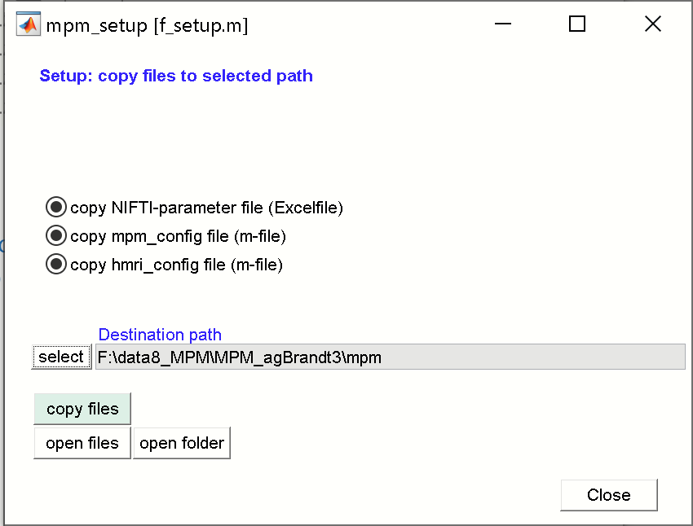

IN the mpm_setup GUI, check that all “copy”-radios are selected. Next, select the destination path by clicking the [**select**]-button. Here select the current study-folder (my folder is “MPM_agBrandt3”). Per default, a “mpm”-folder is added to the path. Next hit [**copy files**] to copy the three files to the new “mpm”-folder within the current study folder. When done hit [**close**]-button to close the setup window.

When done, the new “mpm”-folder of the current study folder will contain 3 files, which have to be modified to run the MPM-wrapper functions. The names of the three files are fixed:

1) “mpm_NIFTIparameters.xlsx”

2) “mpm_config.m”

3) “hmri_local_defaults_mouse.m”

**1) “mpm_NIFTIparameters.xlsx”**

The Excel-file looks as follows:

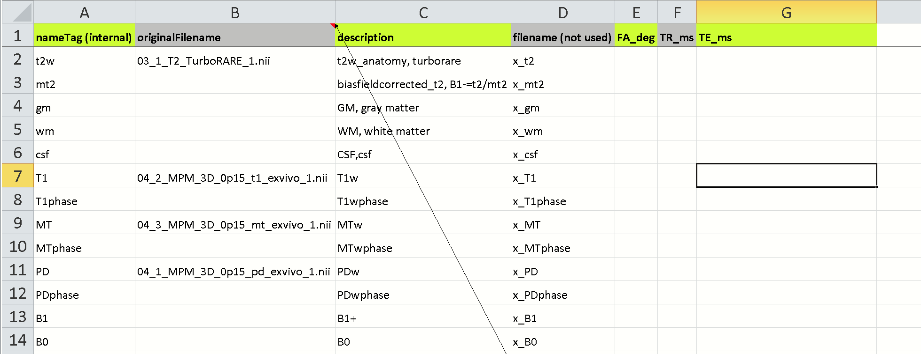

Please enter the original NIFTI-filenames in the 2 column (original Filename). For the current study I inserted the names of:

-turboRARE: ‘03_1_T2_TurboRARE_1.nii’

-T1: ‘04_2_MPM_3D_0p15_t1_exvivo_1.nii‘

-MT: ‘04_3_MPM_3D_0p15_mt_exvivo_1.nii’ and

-PD: ‘04_1_MPM_3D_0p15_pd_exvivo_1.nii’.

The correctness of the NIFTI-filenames in column-2 is important. The Excel-file will later contain important parameters needed for the hMRI-TBX (extracted from the Bruker raw files).

**🡪 When done, please close the excel-document, because parameters will be successively written to this file!**

**2) “mpm_config.m”**

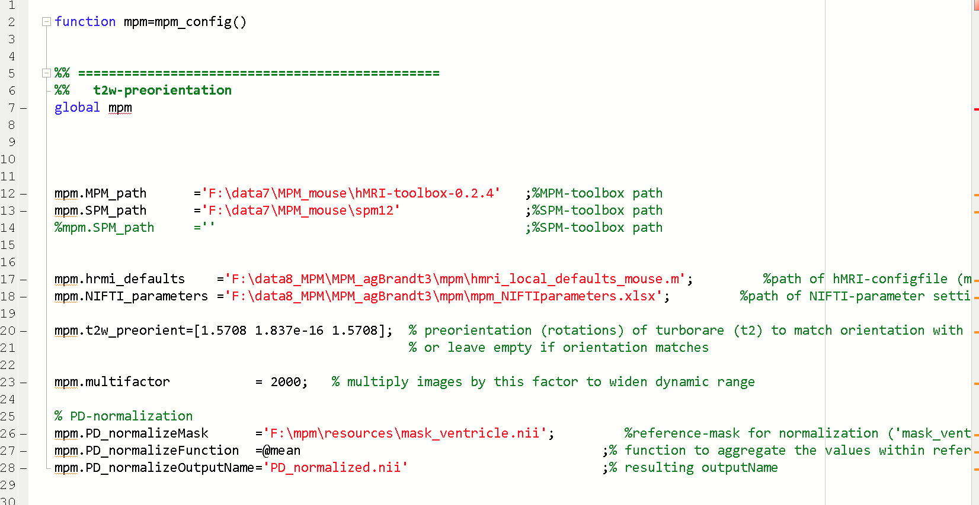

The mpm_config.m file contains parameters that have to be adjusted:

**mpm.MPM_path** ='F:\data7\MPM_mouse\hMRI-toolbox-0.2.4'

-please specify the path of the hMRI-toolbox

**mpm.SPM_path** ='F:\data7\MPM_mouse\spm12' ;%SPM-toolbox path

-please specify the path of SPM12.

-If SPM12 from within ANTx2-toolbox should be used, keep this field empty (mpm.SPM_path ='';)

The **mpm.hrmi_defaults** and **mpm.NIFTI_parameters** should be already defined (after execution of the mpm-setup). These two parameters set the path of the files “hmri_local_defaults_mouse.m” and “mpm_NIFTIparameters.xlsx”, repexctively

mpm.hrmi_defaults ='F:\data8_MPM\MPM_agBrandt3\mpm\hmri_local_defaults_mouse.m'; %path of hMRI-configfile (m-file)

mpm.NIFTI_parameters ='F:\data8_MPM\MPM_agBrandt3\mpm\mpm_NIFTIparameters.xlsx'; %path of NIFTI-parameter settings (Excel file)

For the current study the pre-orientation (three angles) is:

**mpm.t2w_preorient**=[1.5708 0 1.5708];

The **mpm.t2w_preorient** variable defines the rough orientation of the turboRARE-image (used for registration) to match the orientation of PD/T1/MT.

**For further information see “estimate pre-orientation” below.**

The **mpm.multifactor** is set to 2000. This factor is multiplied to the PD/T1/MT-image values to increase the dynamic range.

mpm.multifactor = 2000; % multiply images by this factor to widen dynamic range

**PD-normalization**

For normalization of the PD-image an reference image is necessary that represents a mask of the CSF/ventricles. A ventricle mask exist in the mpm-toolbox and the path is defined in **mpm.PD_normalizeMask**.

**mpm.PD_normalizeMask** ='F:\mpm\resources\mask_ventricle.nii'; %reference-mask for normalization ('mask_ventricle.nii' or

'mask_water.nii' or use your own mask)

mpm.PD_normalizeFunction =@mean ;% function to aggregate the values within reference-mask

mpm.PD_normalizeOutputName='PD_normalized.nii' ;% resulting outputName

The **mpm.PD_normalizeFunction** defines how to aggregate the values within the reference mask (here as mean over values within the mask). The output name of the normalized PD-file is defined in **mpm.PD_normalizeOutputName.**

**3) “hmri_local_defaults_mouse.m”**

This m-file contains parameters for the hmri-toolbox.

Important here is that the parameter **hmri_def.TPM** links to the path of the tissue compartments (contained in the mpm-toolbox):

**hmri_def.TPM**='F:\mpm\resources\mouseTPM_mod.nii';

**LOAD AND RUN THE MPM-PIPELINE**

First select those animals from the ANTx-toolbox (left listbox) that should be processed. Here, all animals (2) were selected. 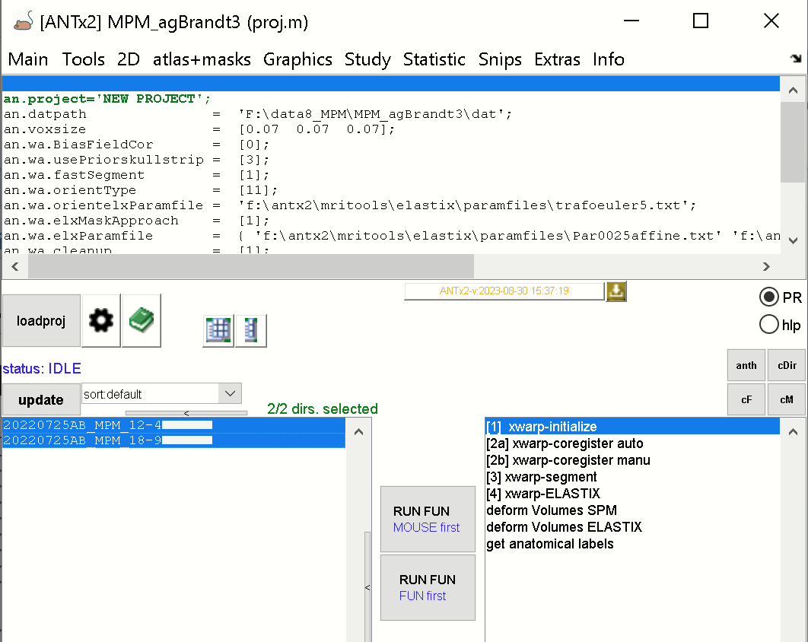

If the mpm-GUI is not open, type “**mpm**” to open the mpm-window.

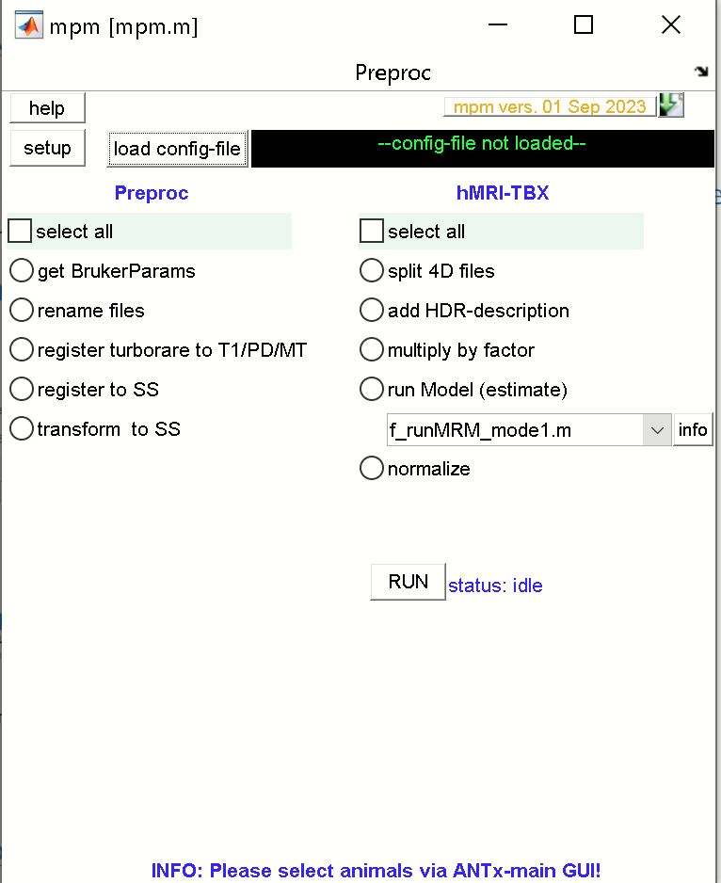

Now, load the mpm-configuration file by clicking the [**load config-file**]-button, and select the “**mpm_configfile.m**” from the studies mpm-folder.

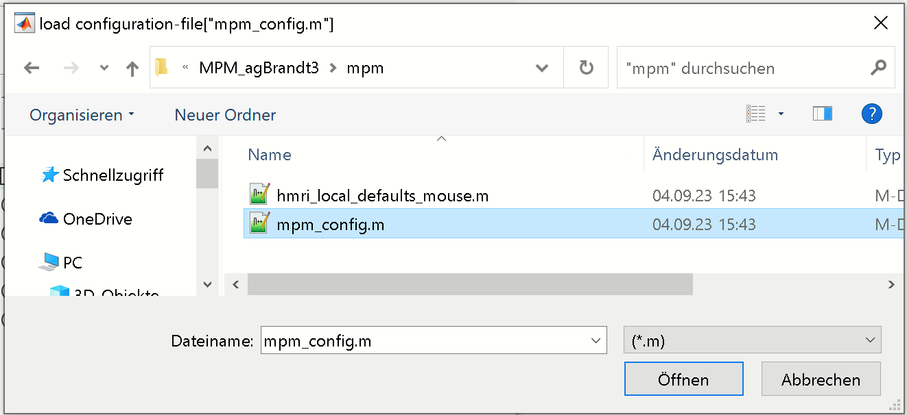

Hit [**open/OK**](“öffnen”)-button.

When done, the green message right to the [load config-file]-button should display the name of the mpm_config-file.

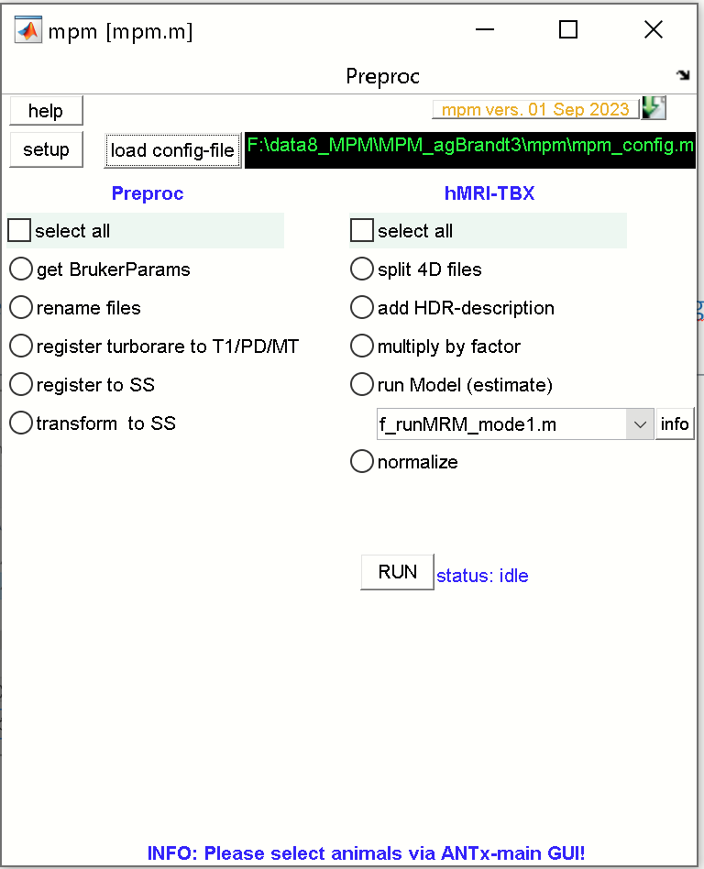

Select all tasks from the preproc-pipeline (left) and the hMRI-pipeline (right) by checking the left and right [**select all]** radios.

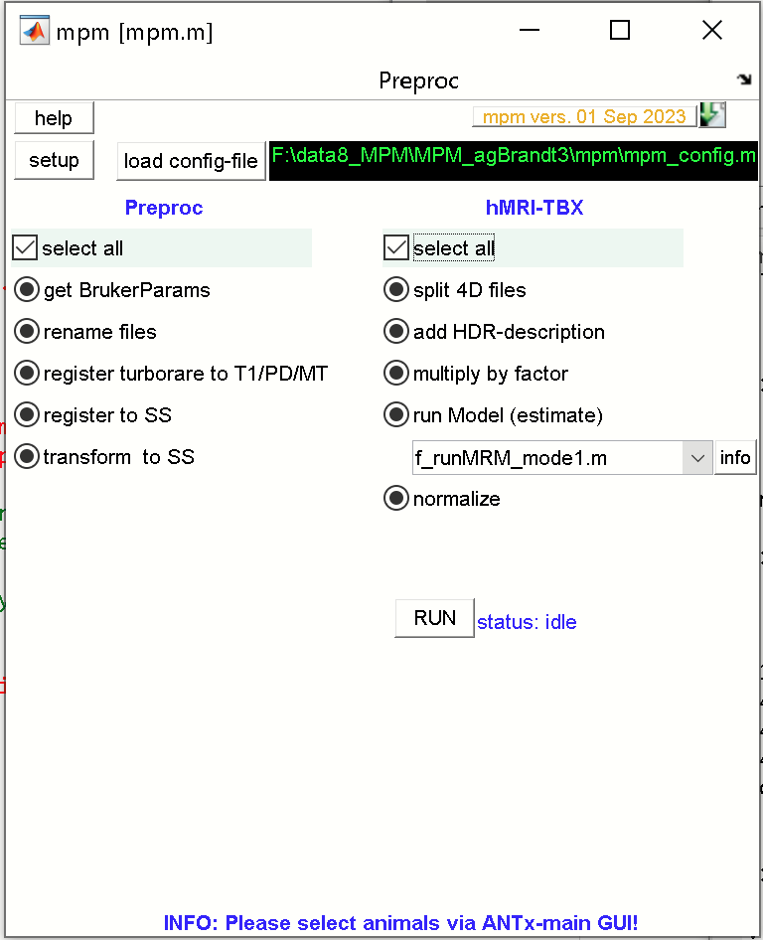

Finally, hit the [**RUN**] from the mpm-GUI to start the processing of all animals selected from the ANTx-GUI.

When the processing is finished, each animal folder will contain a PD-normalized image “PD_normalized.nii” and a subfolder (“Results”) with resulting NIFTI-files.

**Processing steps … some information**

**PREPROC-Processing steps (ANTx is mandatory for the following pre-processing steps)**

All steps must be processed sequentially in that order

**1) get BrukerParams:** This step is done after importing the Bruker raw-data and specifying the NIFTI-files in column-2 of the Excel-file (‘mpm_NIFTIparameters.xlsx’). Based on the Bruker-data and the filenames in the Excel-file (‘mpm_NIFTIparameters.xlsx’), the parameters flip-angle, TR and TE for T1, MT and PD are extracted and written in the respective columns of the Excel file(columns: FA_deg, TR_ms,TE_ms).

**2) rename files**: In the next step, the NIFTI-files (with names defined in column-2 of the excel-file) are copied, and the copies renamed to fixed names ( The fixed names are defined in column-1 of the Excel-file (‘mpm_NIFTIparameters.xlsx’).

Specifically, local copies of the following files are created and new names are given to the copies of the following files:

'03_1_T2_TurboRARE_1.nii' --> 't2w.nii'

'04_2_MPM_3D_0p15_t1_exvivo_1.nii' -->'T1.nii'

'MT 04_3_MPM_3D_0p15_mt_exvivo_1.nii'-->'MT.nii'

'PD 04_1_MPM_3D_0p15_pd_exvivo_1.nii'-->'PD.nii'

**3) register turborare to T1/PD/MT:** In this step the, the turboRARE-image is rigidly registered to T1/PD/MT.

Here it is assumed that T1/PD/MT files are in register towards each other. On the other hand, T1/PD/MT are not in register with the turboRARE image ('t2w.nii') which is later used for registration with the reference/template (here Allen mouse brain, we call this space the “standard-space”). Thus, 't2w.nii' must be registered to T1/PD/MT.

If the orientation is completely different between 't2w.nii' and T1/PD/MT there is the option to add a pre-orientation (3 rotation angles). This pre-orientation has to be defined in the mpm.t2w_preorient-variable (for this study it is: [1.5708 0 1.5708] in the ‘mpm_config.m’-file. 🡪 For more info see “**estimate preorientation**” below.

The resulting output file will be in register with T1/PD/MT and is named ‘t2.nii’.

**4) register to SS:** Next, the ‘t2.nii’-image (i.e. the aligned turboRARE image) is registered to standard-space (SS; i.e. the Allen mouse brain template/atlas). When done, a new file is created (‘x_t2.nii’) which represents the ‘t2.nii’-image in standard-space.

**5) transform to SS**: Based on the previous step, the estimated transformation-parameters (rigid+affine+nonlinear) are used to transform the following files from native-space to standard-space (SS):

‘T1.nii‘, ‘MT.nii‘ , ‘PD.nii‘ to **‘x_T1.nii‘, ‘x_MT.nii‘ , ‘x_PD.nii**‘, respectively.

Aside this, the “register to SS” step created a biasfield-corrected ‘t2.nii’-image (‘mt2.nii’, obtained via SPM’s Unified Approach which is also transformed to standard-space **(‘x_mt2.nii’)**

**hMRI-Processing steps (with or without ANTx)**

**6) split 4D files:** Here the 4D-volumes **‘x_T1.nii‘, ‘x_MT.nii‘ , ‘x_PD.nii‘** are split into 3D-volumes (x_T1_00001.nii, x_T1_00002.nii…etc.; x_MT1_00001.nii, x_MT1_00002.nii…etc.; x_PD1_00001.nii, x_PD1_00002.nii…etc.) because the hMRI-tbx used 3D data.

**7) add HDR-description:** The parameters flip-angle, TR and TE for T1, MT and PD (which were previously written to the Excel-file (‘mpm_NIFTIparameters.xlsx’, **see get BrukerParams** ) are written to the header of x_T1, x_MT and x_PD images.

**8) multiply by factor**: In the next step, a factor is multiplied to the values of the of x_T1, x_MT and x_PD images to increase the dynamic range. Note that the factor is defined in the “mpm_config.m”-file (mpm.multifactor = 2000).

The factor is also stored in the header of the images to allow to rerun this step and prevent multiple, sequential multiplications of the same image with a factor.

**9) run Model (estimate):** Currently there is only one hMRI-implementation available 'f_runMRM_mode1.m'. Hit the [**info**]-button for more information.

Basically all images have to be in standard space (SS). The following inputs are used:

[**RF**]: 'x_t2.nii' and 'x_mt2.nii'

'x_t2.nii' - is the t2-weighted image in SS

'x_mt2.nii' - is the bias-corrected t2-weighted image in SS ('mt2.nii' is generated using SPM's Unified Approach)

[**B1-Bias correction**]: #r - B1-bias correction is not used here. I.e. the input is 'noB1'

[**raw_mpm**]: PD, MT and T1 data in SS are used, i.e. multiple 3D-volumes for each modality are used:

'x_PD_00001.nii' , 'x_PD_00002.nii' , 'x_PD_00003.nii' ...etc.

'x_MT_00001.nii' , 'x_MT_00002.nii' , 'x_MT_00003.nii' ...etc.

'x_T1_00001.nii' , 'x_T1_00002.nii' , 'x_T1_00003.nii' ...etc.

The SPM-job (job.mat) of 'f_runMRM_mode1.m' is created, variables are inserted and saved in the mpm-folder of the study (here: F:\data8_MPM\MPM_agBrandt3\mpm). Finally, the SPM-job is executed.

Here is the the exemplary SPM-job of 'f_runMRM_mode1.m' for the current data:

matlabbatch{1}.spm.tools.hmri.hmri_config.hmri_setdef.customised = {'F:\data8_MPM\MPM_agBrandt3\mpm\hmri_local_defaults_mouse.m'};

matlabbatch{2}.spm.tools.hmri.create_mpm.subj.output.indir = 'yes';

matlabbatch{2}.spm.tools.hmri.create_mpm.subj.sensitivity.RF_once = {

'F:\data8_MPM\MPM_agBrandt3\dat\20220725AB_MPM_18-9\x_t2.nii'

'F:\data8_MPM\MPM_agBrandt3\dat\20220725AB_MPM_18-9\x_mt2.nii'

};

matlabbatch{2}.spm.tools.hmri.create_mpm.subj.b1_type.no_B1_correction = 'noB1';

matlabbatch{2}.spm.tools.hmri.create_mpm.subj.raw_mpm.MT = {

'F:\data8_MPM\MPM_agBrandt3\dat\20220725AB_MPM_18-9\x_MT_00001.nii'

'F:\data8_MPM\MPM_agBrandt3\dat\20220725AB_MPM_18-9\x_MT_00002.nii'

'F:\data8_MPM\MPM_agBrandt3\dat\20220725AB_MPM_18-9\x_MT_00003.nii'

'F:\data8_MPM\MPM_agBrandt3\dat\20220725AB_MPM_18-9\x_MT_00004.nii'

'F:\data8_MPM\MPM_agBrandt3\dat\20220725AB_MPM_18-9\x_MT_00005.nii'

'F:\data8_MPM\MPM_agBrandt3\dat\20220725AB_MPM_18-9\x_MT_00006.nii'

};

matlabbatch{2}.spm.tools.hmri.create_mpm.subj.raw_mpm.PD = {

'F:\data8_MPM\MPM_agBrandt3\dat\20220725AB_MPM_18-9\x_PD_00001.nii'

'F:\data8_MPM\MPM_agBrandt3\dat\20220725AB_MPM_18-9\x_PD_00002.nii'

'F:\data8_MPM\MPM_agBrandt3\dat\20220725AB_MPM_18-9\x_PD_00003.nii'

'F:\data8_MPM\MPM_agBrandt3\dat\20220725AB_MPM_18-9\x_PD_00004.nii'

'F:\data8_MPM\MPM_agBrandt3\dat\20220725AB_MPM_18-9\x_PD_00005.nii'

'F:\data8_MPM\MPM_agBrandt3\dat\20220725AB_MPM_18-9\x_PD_00006.nii'

'F:\data8_MPM\MPM_agBrandt3\dat\20220725AB_MPM_18-9\x_PD_00007.nii'

'F:\data8_MPM\MPM_agBrandt3\dat\20220725AB_MPM_18-9\x_PD_00008.nii'

};

matlabbatch{2}.spm.tools.hmri.create_mpm.subj.raw_mpm.T1 = {

'F:\data8_MPM\MPM_agBrandt3\dat\20220725AB_MPM_18-9\x_T1_00001.nii'

'F:\data8_MPM\MPM_agBrandt3\dat\20220725AB_MPM_18-9\x_T1_00002.nii'

'F:\data8_MPM\MPM_agBrandt3\dat\20220725AB_MPM_18-9\x_T1_00003.nii'

'F:\data8_MPM\MPM_agBrandt3\dat\20220725AB_MPM_18-9\x_T1_00004.nii'

'F:\data8_MPM\MPM_agBrandt3\dat\20220725AB_MPM_18-9\x_T1_00005.nii'

'F:\data8_MPM\MPM_agBrandt3\dat\20220725AB_MPM_18-9\x_T1_00006.nii'

'F:\data8_MPM\MPM_agBrandt3\dat\20220725AB_MPM_18-9\x_T1_00007.nii'

'F:\data8_MPM\MPM_agBrandt3\dat\20220725AB_MPM_18-9\x_T1_00008.nii'

};

matlabbatch{2}.spm.tools.hmri.create_mpm.subj.popup = false;

**10) normalize:** This step creates a normalizes PD-image ‘PD_normalized.nii’. For this step, a reference-mask has to be provided. The path of the reference mask (NIFTI-file) is specified in mpm_config.m-file (variable: ‘mpm.PD_normalizeMask’). The ventricle-mask ('mask_ventricle.nii', located in the mpm-tbx) is configured as the default reference mask.

Note: If another mask is used as reference mask, it must have the following properties:

-binary 3D NIFTI-image, with values equal to ‘1’ referring to reference-regions such as ventricles

-mask must be in standard space (SS), i.e. in register with the template, x_t2.nii etc.

-same voxel-size as x, _t2.nii, x_T1,x_MT and x_PD images.

**Misc: “estimate pre-orientation”**

The **mpm.t2w_preorient** variable (mpm_config.m-file) defines the rough orientation of the turboRARE-image (used for registration) to match the orientation of the PD/T1/MT images. In the above examples the pre-orientation was set as:

mpm.t2w_preorient=[1.5708 0 1.5708]. It is also assumed that the pre-orientation is roughly the same across animals within the same study, i.e. all animals are more or less identically positioned in the MR-bore.

To estimate the pre-orientation do the following:

1) load the ANTx-project of the study.

2) Select one animal from the left animal listbox

3) Start the mpm-GUI (Note: All other parameters should be specified in the “mpm_config.m” and the filenames in the Excel file), and load the mpm_config.m-file

4) from mpm-GUI run “rename files” for this animal. This is necessary to work with simpler filenames such as “T1.nii” and “t2w.nii” in the next step

5) In Matlab command window type “**f_estimPreorient**” or from **mpm-MENU** select PREPROC/ 'estimate pre-orientation t2w to T1/PD/MT'. When done, you will see the images “t2w.nii” and “T1.nii” (1st image) side-by-side:

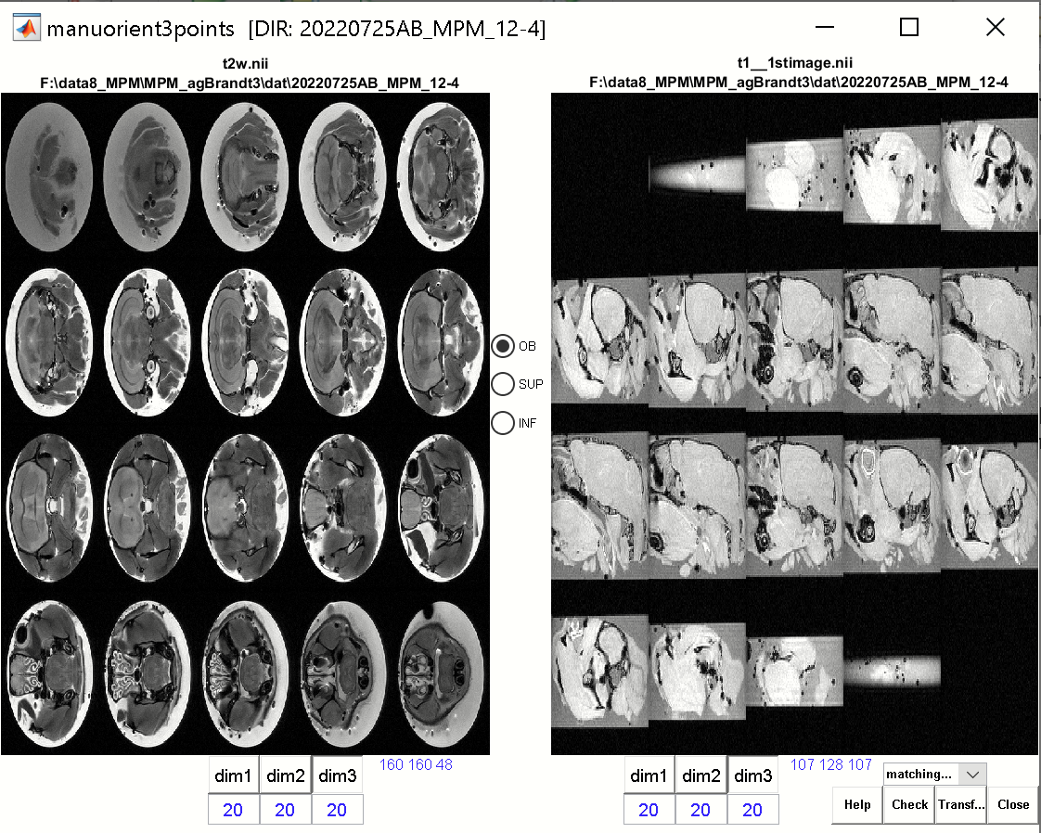

In the right image hit [**dim2**]-button to obtain a similar dimensional view as for the left side (coronal view is preferred for both images).

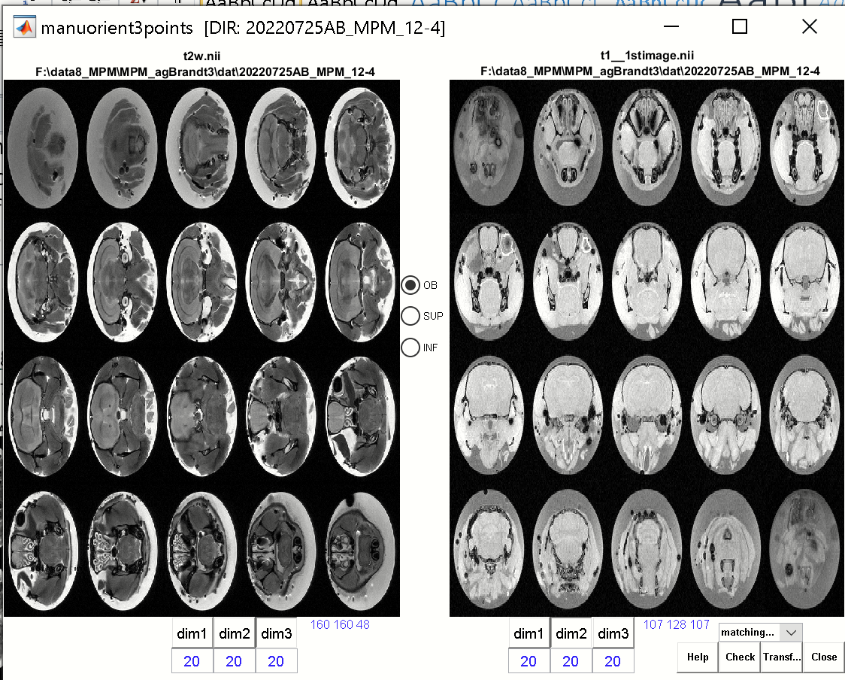

Now, you have to set 3 corresponding points (OB, SUP and INF) in the left and right image. These points need only to roughly match!

First click the [**OB**]-radio (located between images) and select a corresponding/similar location of the olfactory bulbus in the left and right images (red dots).

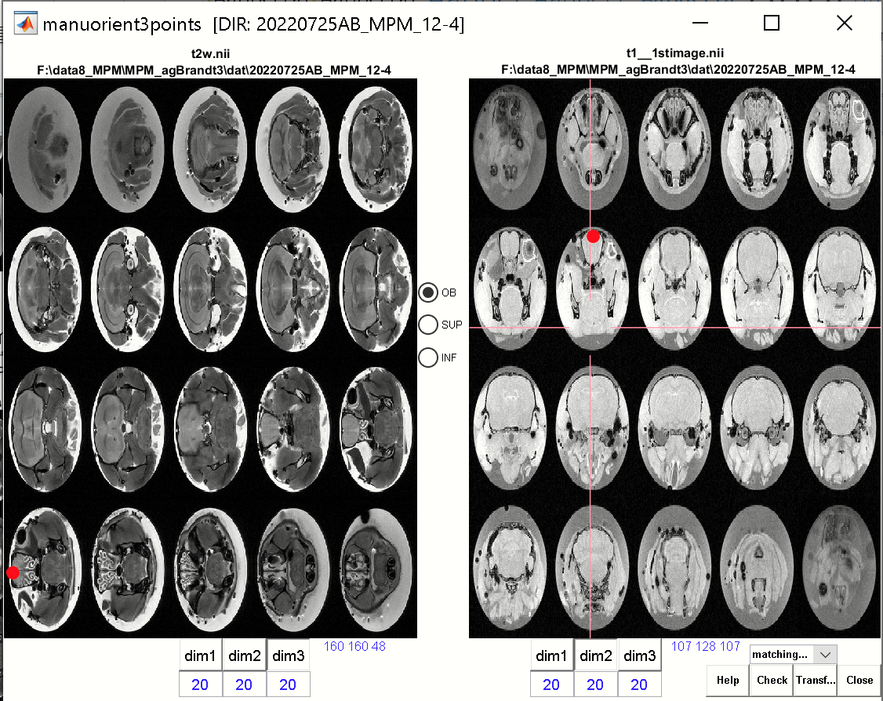

Next, hit the [**SUP**]-button and select a superior midbrain location in both images (green dots).

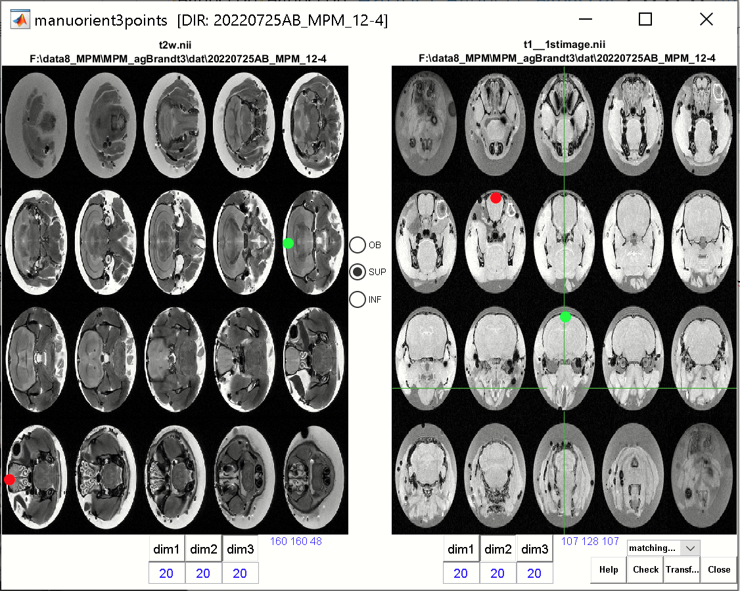

Finally, hit the [**INF**]-button and select an inferior midbrain location in both images (blue dots). Note that green and blue dots are on the same slice in both images.

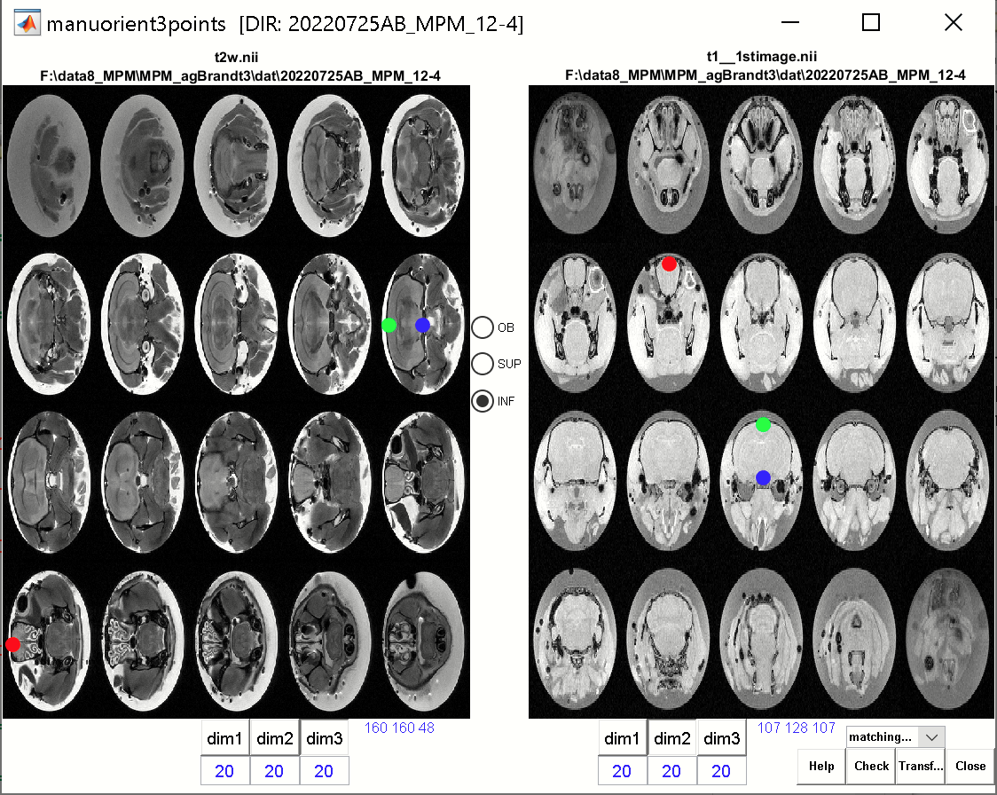

From the pulldown menu (“matching..”) select “**MRIcron**” and hit the [**check**]-button. MRIcron will open and shows the overlay of the 1st image and a rotated version of the 2nd image. Based on the match of the overlay, the pre-orientation seems to be sufficient.

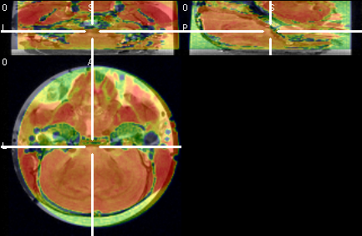

When hitting the [check]-button, the three rotation-angles will be displayed in the Matlab command window: **ROTATIONS: [1.5708 1.837e-16 1.5708,]**. I.e. a rotation of approx. [1.57 0 1.57] radians is necessary to reorient the “t2w.nii” image such that is has the same orientation as PD/T1/MT (This pre-orientation is later used for the registration of “t2w.nii” to PD/T1/MT).

When done, close the window and manually insert the three angles in the **mpm.t2w_preorient** variable in the **mpm_config.m**-file.

Note:

-This step has to be done only, if turboRARE and the PD/T1/MT images have different orientations

-This step has to be done only once per study assuming that all animals are positioned more or less identical into the bore

**II) Working without the pre-processing steps (ANTx is not necessary)**

The following workflow works **without** ANTx-TBX and can be used when the following images exist in standard-space:

x_MT.nii : 4D MT-volume in standard-space

x_T1.nii : 4D T1-volume in standard-space

x_PD.nii : 4D PD-volume in standard-space

x_t2.nii : turboRARE in standard-space

x_mt2.nii : bias-corrected turboRARE in standard-space (created for example using SPM’s unified Approach)

For example: The following study-folder “**F:\data8_MPM\MPM_agBrandt4_noANTx”** contains a ‘dat’-folder with the animal-folders: ‘20220725AB_MPM_12-4’ and ‘20220725AB_MPM_18-9’. Each of the animal folders contain the following files: x_MT.nii, x_T1.nii, x_PD.nii , x_t2.nii and x_mt2.nii.

**SET MPM-PATH**

-add MPM-path via hyperlink or go to mpm-folder and type “**mpmlink**” (this will set the paths of mpm)

-in Matlab command window type ‘**mpm’** to open the mpm-GUI.

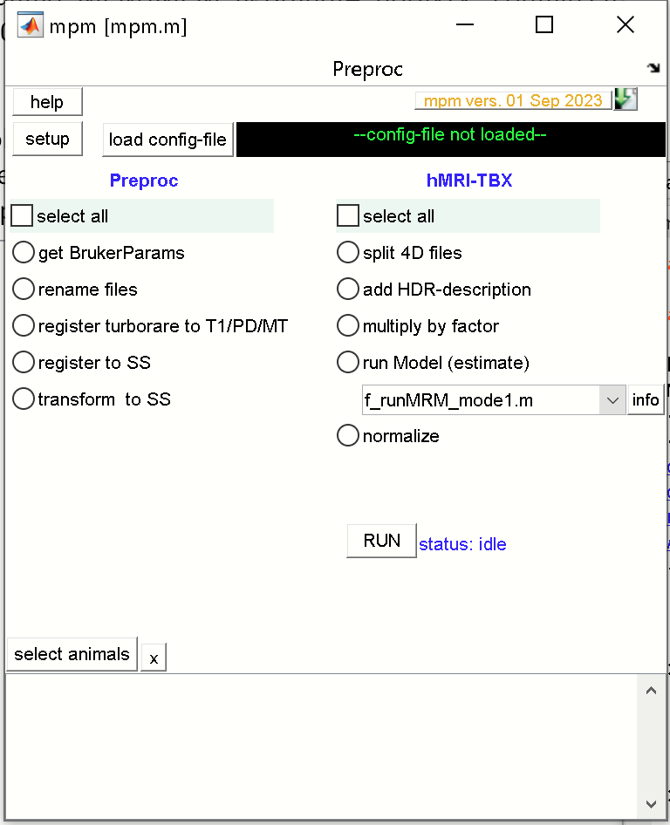

- Set Matlab’s current working dir to the studies folder: Here: ‘F:\data8_MPM\MPM_agBrandt4_noANTx’.

**SETUP and configuration**

Hit the [setup]-button from the mpm-GUI.

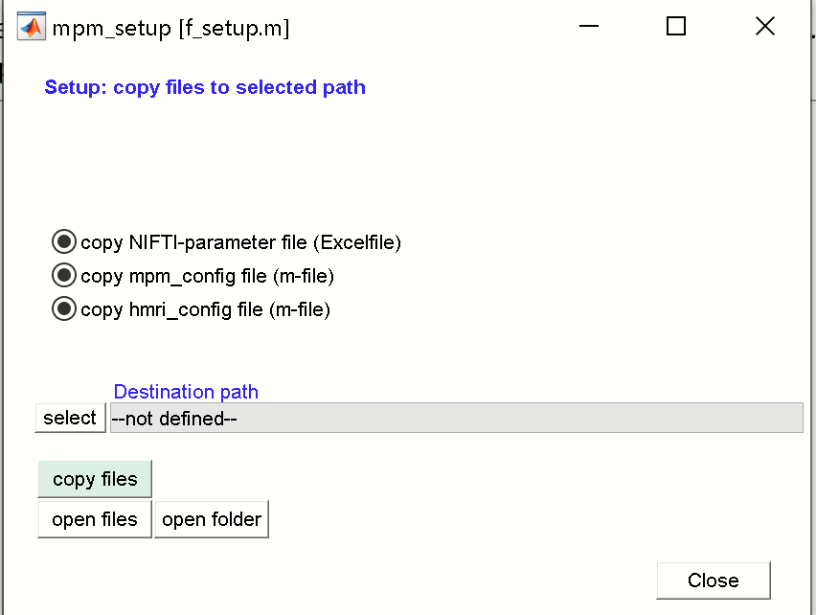

Hit the [**select**]-button to set the destination path and select the study-folder

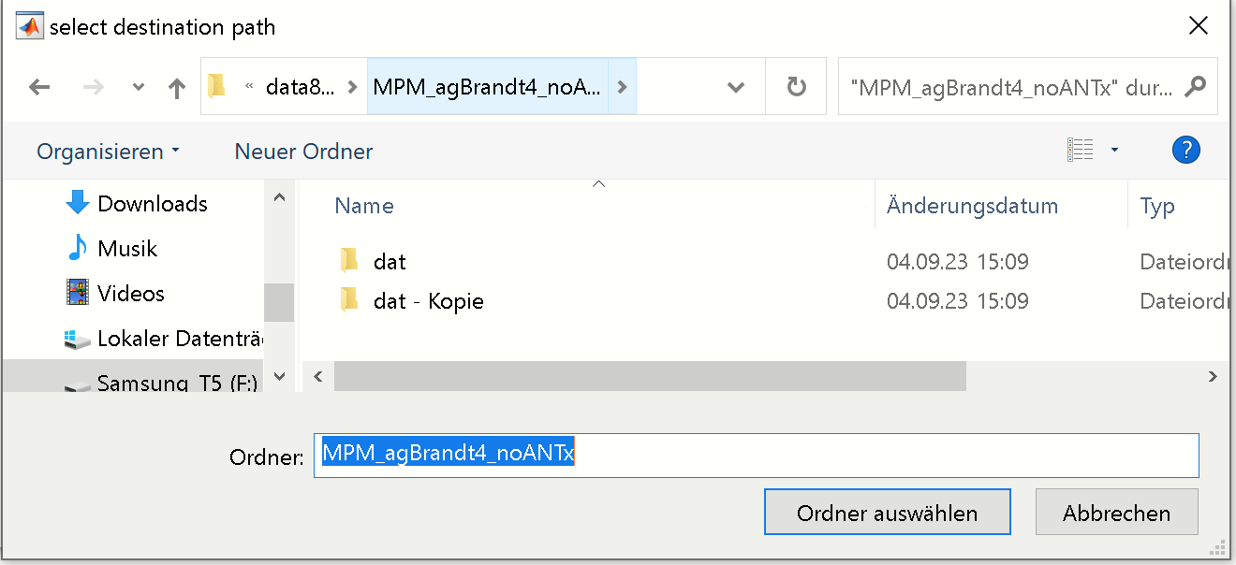

Hit [**select**]/[Ordner auswählen].

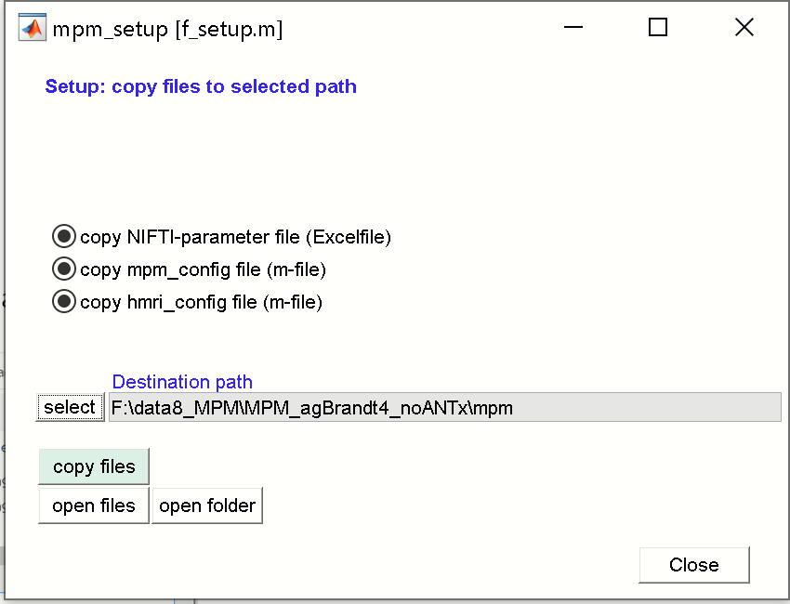

Hit the [**copy files**]-button to copy 3 documents to the study’s mpm-folder. Hit [**close**]-button to close the setup window. The study folder should now contain a folder ‘mpm’ with the following documents:

-‘mpm_NIFTIparameters.xlsx’

-‘mpm_config.m’

-‘hmri_local_defaults_mouse.m’

**1) ‘mpm_NIFTIparameters.xlsx’**

The Excel-file looks as follows:

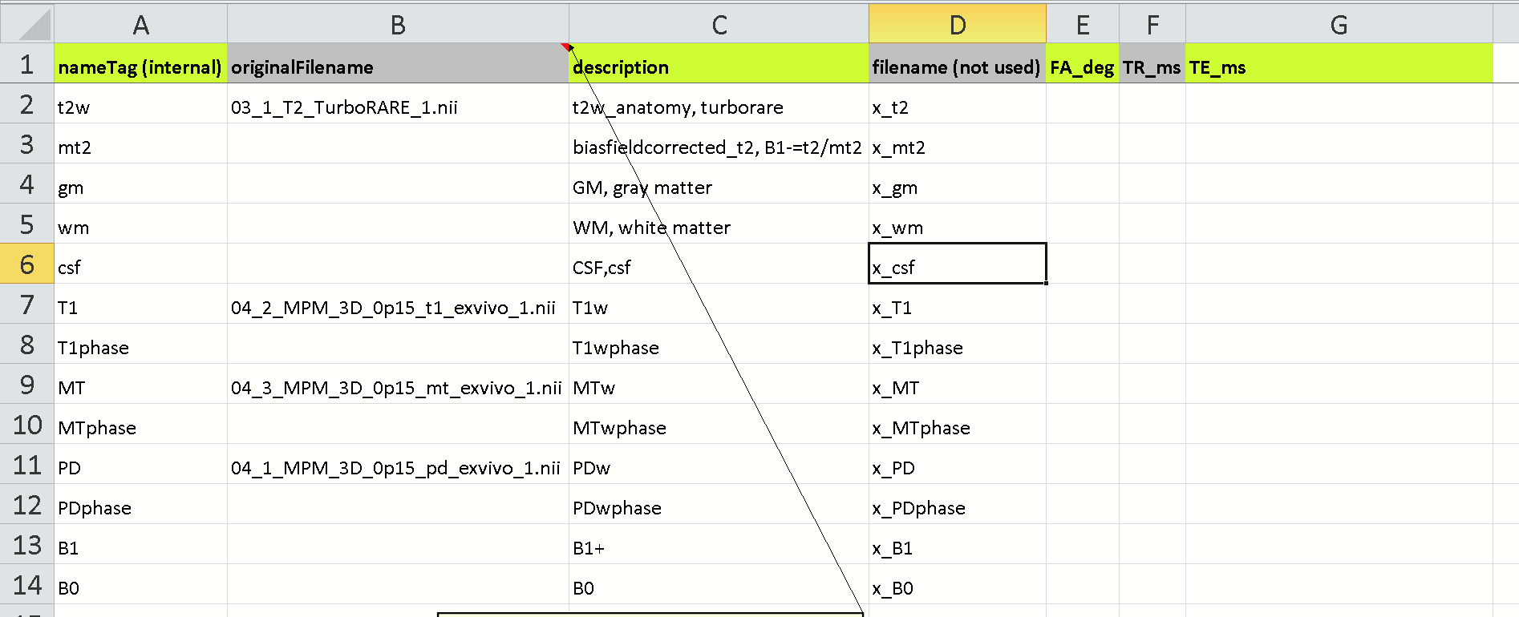

The 4th column specifies the file-names in standard-space. Please do not change the names in column-4, rather change the names of the files in the ‘dat’-folder (corresponding to column-4). Next, add the parameters flip angle, TR and TE manually.

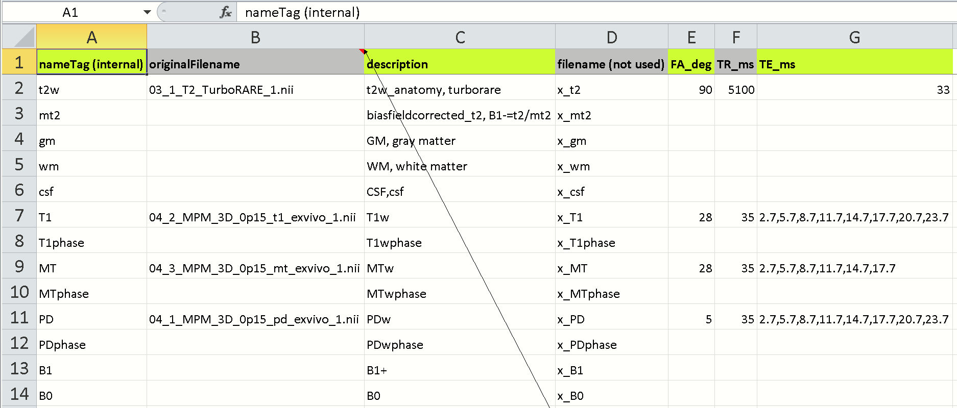

Save and close the excel-file.

**2) ‘mpm_config’**

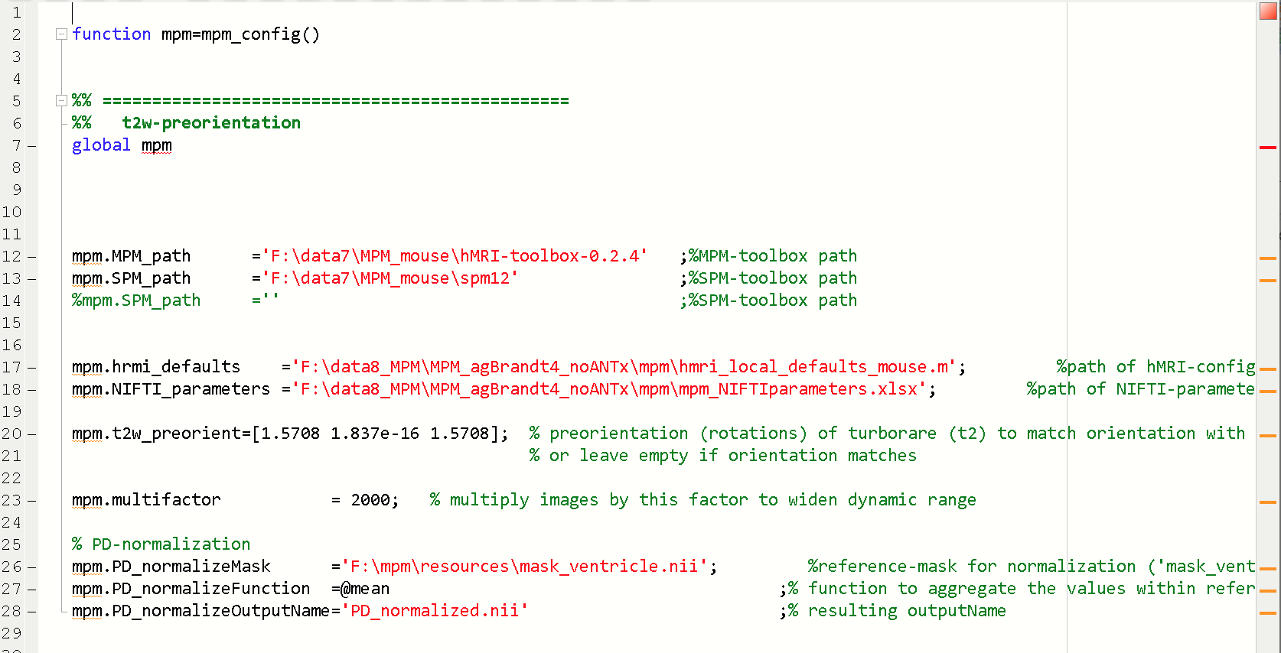

The mpm_config.m file contains parameters that have to be adjusted:

**mpm.MPM_path** ='F:\data7\MPM_mouse\hMRI-toolbox-0.2.4' ;%MPM-toolbox path

-please specify the path of the hMRI-toolbox-0.2.4

**mpm.SPM_path** ='F:\data7\MPM_mouse\spm12' ;%SPM-toolbox path

-please specify the path of SPM12.

The **mpm.hrmi_defaults** and **mpm.NIFTI_parameters** should be already defined (after the mpm-setup), and link to the files “hmri_local_defaults_mouse.m” and “mpm_NIFTIparameters.xlsx”:

mpm.hrmi_defaults ='F:\data8_MPM\MPM_agBrandt4_noANTx\mpm\hmri_local_defaults_mouse.m'; %path of hMRI-configfile (m-file)

mpm.NIFTI_parameters ='F:\data8_MPM\ MPM_agBrandt4_noANTx\mpm\mpm_NIFTIparameters.xlsx'; %path of NIFTI-parameter settings (Excel file)

The **mpm.t2w_preorient** variable defines the rough orientation of the turboRARE-image (used for registration) to match the orientation of PD/T1/MT.

mpm.t2w_preorient=[1.5708 0 1.5708]; % preorientation (rotations) of turboRARE (t2) to match orientation with PD/T1/MT-images. **HERE, the images are already in Standard space, so there is no need to change/modify this variable.**

The **mpm.multifactor** is set to 2000. This factor is multiplied to the PD/T1/MT-image values to increase the dynamic range.mpm.multifactor = 2000; % multiply images by this factor to widen dynamic range

**PD-normalization**

For normalization of the PD-image a reference image is necessary that represents a mask of the CSF/ventricles. A ventricle mask exists in the mpm-toolbox and the path is defined in **mpm.PD_normalizeMask**.

mpm.PD_normalizeMask ='F:\mpm\resources\mask_ventricle.nii'; %reference-mask for normalization ('mask_ventricle.nii' or

'mask_water.nii' or use your own mask)

mpm.PD_normalizeFunction =@mean ;% function to aggregate the values within reference-mask

mpm.PD_normalizeOutputName='PD_normalized.nii' ;% resulting outputName

The **mpm.PD_normalizeFunction** defines how to aggregate the values within the reference mask (here as mean over values within the mask). The output name of the normalized PD-file is defined in **mpm.PD_normalizeOutputName.**

**3) “hmri_local_defaults_mouse.m”**

This m-file contains parameters for the hmri-toolbox.

Important here is that the parameter hmri_def.TPM links to the path of the tissue compartments (contained in the mpm-toolbox):

**hmri_def.TPM**='F:\mpm\resources\mouseTPM_mod.nii';

**Loading the ‘mpm_config.m’-file**

In the mpm-gui hit the [**load config-file**]-button and select the ‘**mpm_config.m’**-file. Hit [**open**]/[öffnen] to load the configuration.

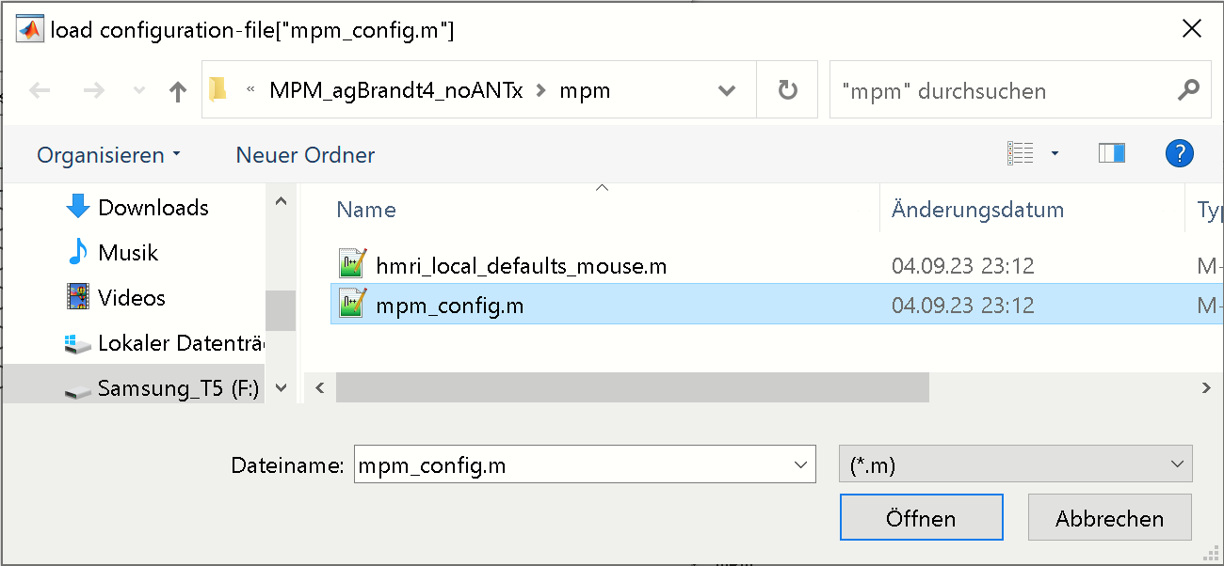

When done, the mpm-GUI should display the path of the config-file right to the [load config-file] button.

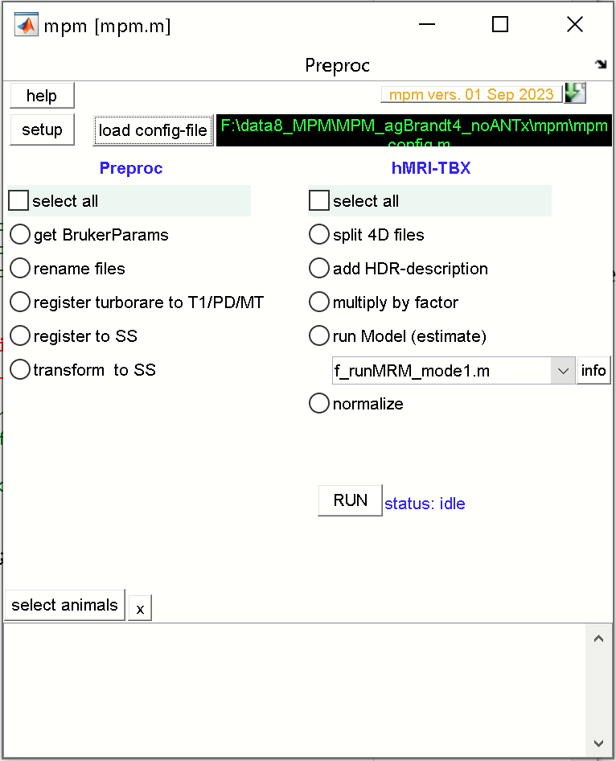

**Select animals for processing**

From mpm-GUI hit the [**select animals**] button. In the animal-selection GUI navigate to the studies ‘**dat’**-folder (left listbox). Now select the two animals from the right listbox

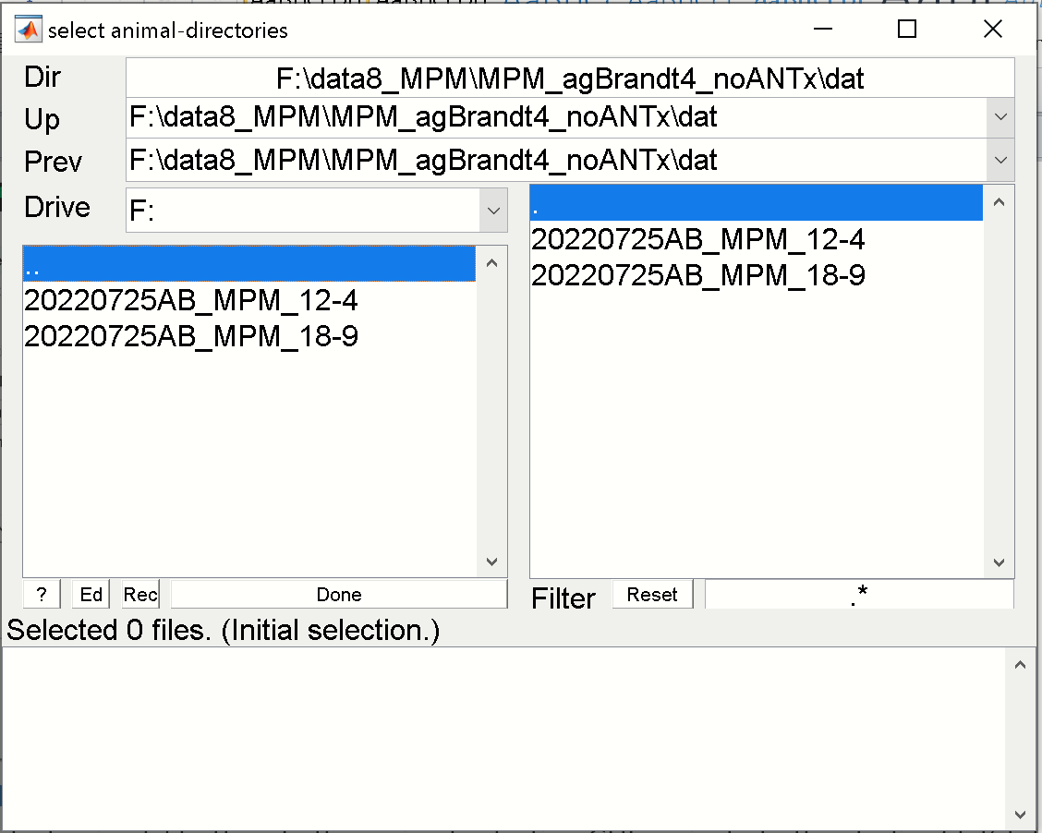 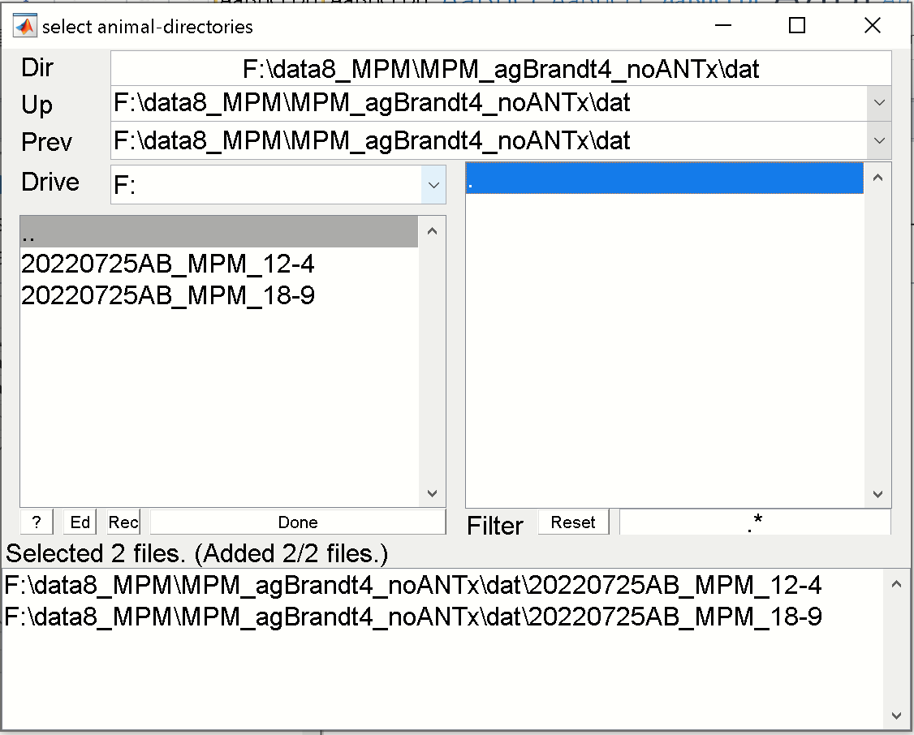

When selected, the two animals disappear in the right listbox and reappear in the lower listbox. Hit [**Done**]-button.

The animal-listbox in the mpm-GUI should now contain the selected animals for processing. Here two animals were selected).

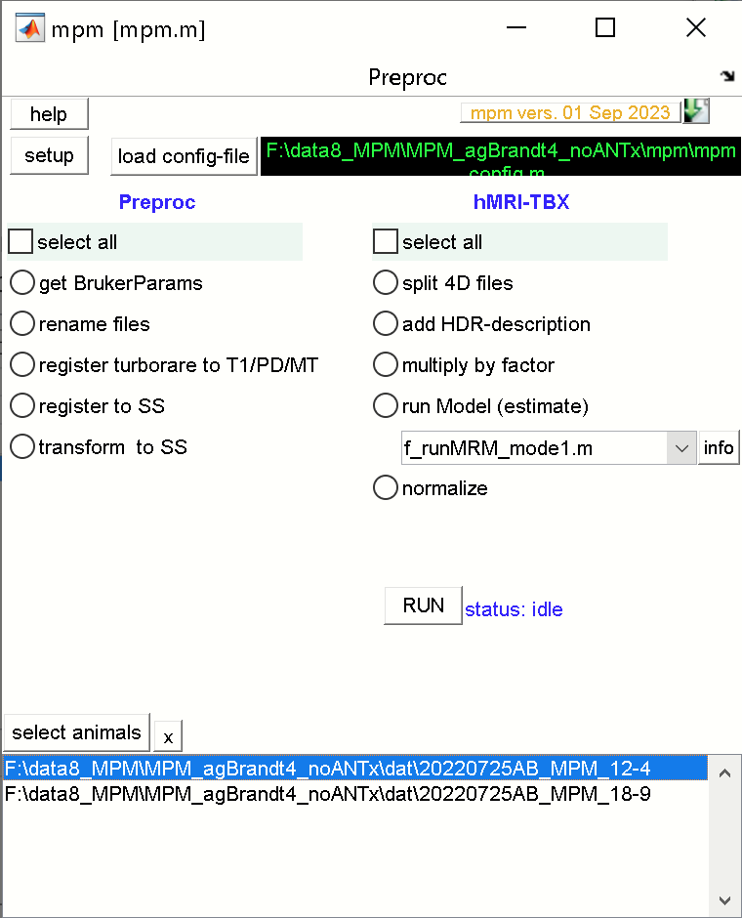

**RUN the hMRI-processing steps**

From the hMRI-TBX processes (right side) check the [**select all**]-radio to run all processing steps.

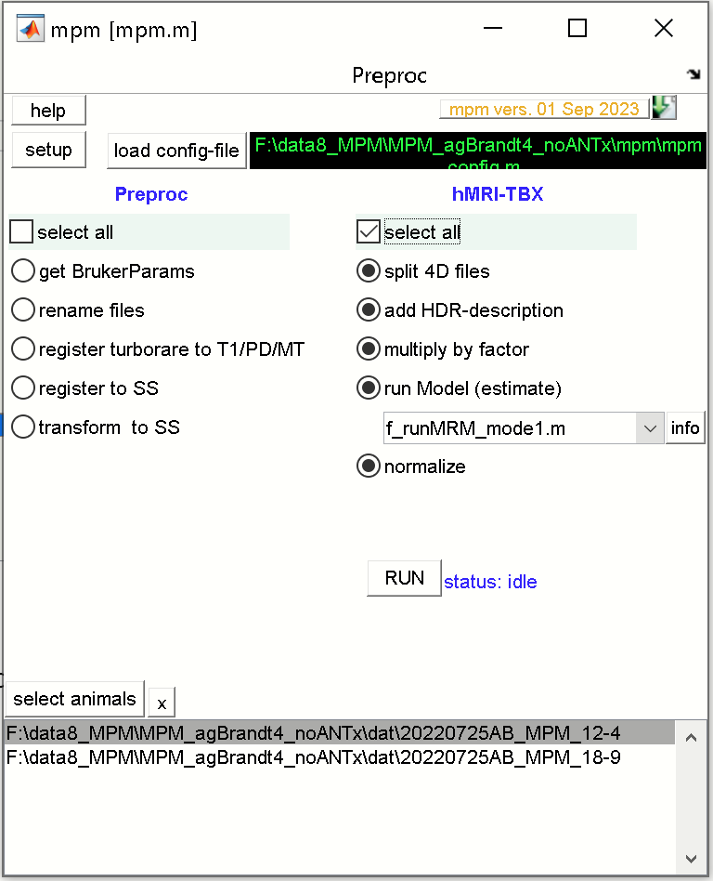

Hit [**RUN**] to execute all selected processing steps for the selected animals.